Hello,

I am trying to connect UiPath to alteryx.

I put an Alteryx Application Scope and I see this:

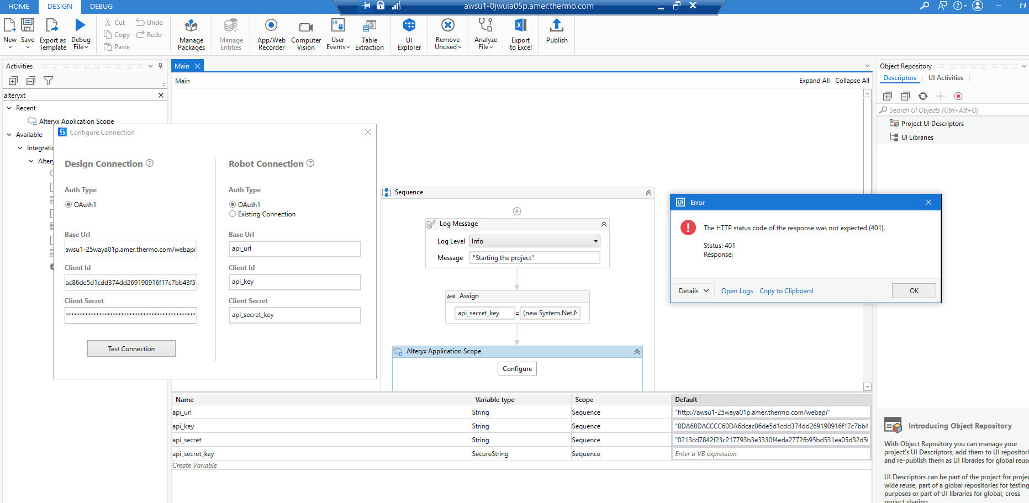

Error:

21.4.5+Branch.support-v21.4.Sha.31d3be059a971ae7159b5b4a841a4327a74b8179

The HTTP status code of the response was not expected (401).

Status: 401

Response:

Error: System.Exception: The HTTP status code of the response was not expected (401).

Status: 401

Response:

, HResult -2146233088

I had a chat with Alteryx and they told me that Alteryx only accpets Oauth2.

Could this be the reason that I cannot connect to Alteryx?

Client ID, url and Client Secret keys are correct.

Any ideas?

Thank you very much!

Luis Martirena

Thermo Fisher Scientific